EQUAL EDUCATION OPPORTUNITIES FOR STUDENTS AT (VILLAGE) HOME WITH ICT

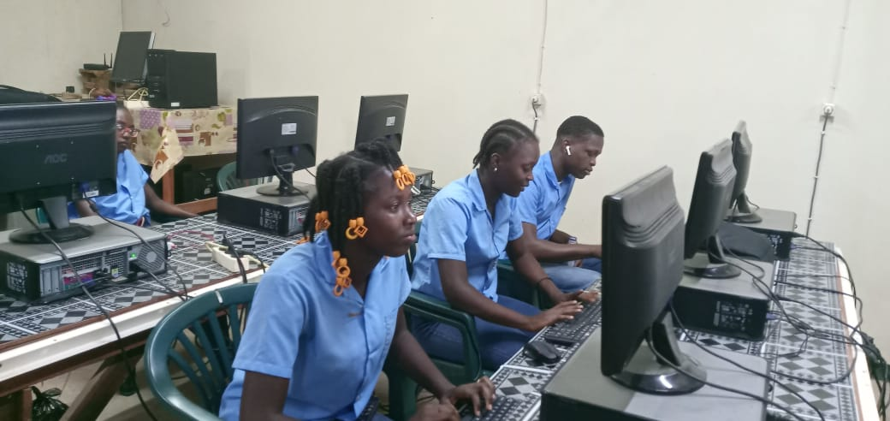

Apinsa Urtha
Kastierie Inice
Molien Noreen
Rozenhout Andielle

Project Mentors
Faculty Mentor/Mentors
Mr .Padhu Seshaiyer
Mr .Julian Mclean
Mevr .Yu-Ann Okuma

Abstract

The students in the interior must reach the same level as the students in the city because education focuses on the whole child, the social emotional, mental, physical cognitive development of each child, regardless of gender, race ethicaland, or social. It prepares the child for life, Sdg 4 quality education .
We have chosen for:

1.methods of differentiation that is the way in which a teacher consciously, positively and systematically deals with the cognitive, metacognitive,motivational and cultural differences between learners.
2.Biling education:the students learn part of another language. This will be Dutch and the language spoken in the area (village)

Every student is included in the lesson despite what level, culture, language use, so you see that all students are given the opportunity to take advantage of their opportunities, you see that no one is skipped. This way they are stimulated to better opportunities and achieve results

despite all the situations in the interior, the teachers have to
meet the students with new methods, creativity, technology so that they all have a chance and stay motivated, despite being in the interior.

Introduction

Studies has shown that students in the interior have a learning backlog because they are far from the city .We have choose two village (Petondro and Tamarin)for a pilot project in collaboration with telesur and EBS,we check whether the Internet connection is stable and the power consumption, then make sure that every village has an ICT room

Our project is to give the pupils in the interior equal opportunities as the pupils in the. city so that they do not lag behind in terms of education and ICT in the various subjects. These pupils can then enjoy education with ICT in a motivated way and especially if they have passed and have to go to the city for further education.

After covid 19 and water nuisance in the interior, we have a family that the students are behind.. Most of the teachers who teach in those areas are not local and then these problems then they pull back so the students are lagging behind.

We have opted for equal opportunities in education and ICT. Because the students have to get all major subjects, so that they can join the lessons and apply every year if they are promoted to the next grade. And discuss the nature of the project and different aspects of the project. We have 2 villages chosen because they are 2 small villages where we involve the parents to help encourage the students to do their best.

.We chose this project because the students in the interior are usually not counted. They have disadvantages, which is why we have opted for equal education and ICT opportunities for these students at home.

https://www.edukans.nl/project/verbetering-onderwijs-binnenland-suriname/

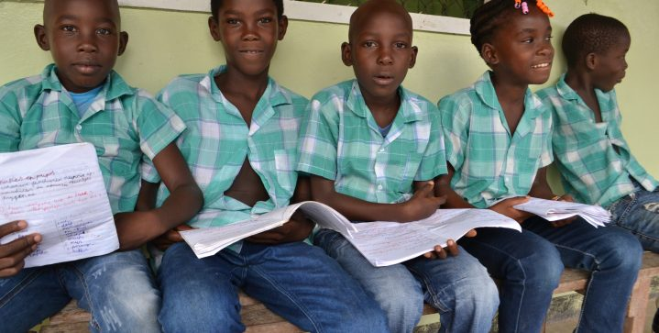
  - Finish with an outline on how the Project Report is structured

- PROJECT PLANNING (WHAT)
better education and more children inland

- Our big idea

At the
    - Begin with the end in mind and plan for this end result.
by providing a safe and healthy learning environment, training teachers, good teaching materials and involving the community.

    - Project goals
We want a solid ICT classroom for the pupils so they can follow lessons in a child-friendly environment. we know that not only for ICT we need electricity for this children but also to do their homework, to watch tv ect.
there will be:
Good electricity for these villages.
Enough computers for every pupil.
Security for the ICT room.

the learning outcomes
- the students should know what a computer is
- they also have to know or recognize the letters of desk (computer)
- after talking about the computer with them they must answer a few Questions about the computer
- They will make a paper on a computer.

    - Describe assessment criteria
The assessment criteria will be the paper that they shall make
  - Explain how to integrate content and learning to accomplish the Big Idea.
The domestic pupils will do some projects with pupils of other districts.
    - Present an educational framework you plan to use
Every month (the last Friday)they will do projects in groups and then they will be put in groups with pupils of their district to make a project and present it.
    - Why is this framework the optimal choice for your project?
so that they will not only work with each other but also with other pupils from another neighborhood online.

    - Generate/Rank Hypothesis
  - Present a background on the tools, skills and competencies that you learnt from the class to be integrated in the pro

    - Kwl,Empathy map,Fishbone,Smart
K | W | L
we know that these villages have no local ICT and no optimal electricity | We want a solution for the problem | We have learned that you have to look for a solution when you have a problem

S M A R T
S= specific :Building an IT room
M=measurable :Through the two pilot schools with which we will start
A= achievable :The teachers find it easier to work and the students are enthusiastic about working online
R=relevant : 2 (Two) pilot school
T=time:5 months

    - Describes project launch, sequence of activities and benchmarks
we as teachers of the village are going to furnish a classroom together with the residents of the village into a suitable ICT space. child-friendly with pictures and certainly also information about the computer and space.

    - What is the scope of the project? Create a chart if you can.
So we will work on a pilot project and those will be the two schools we have chosen in the interior, if it succeeds at those schools we will provide all other schools in Marowijne.

    - 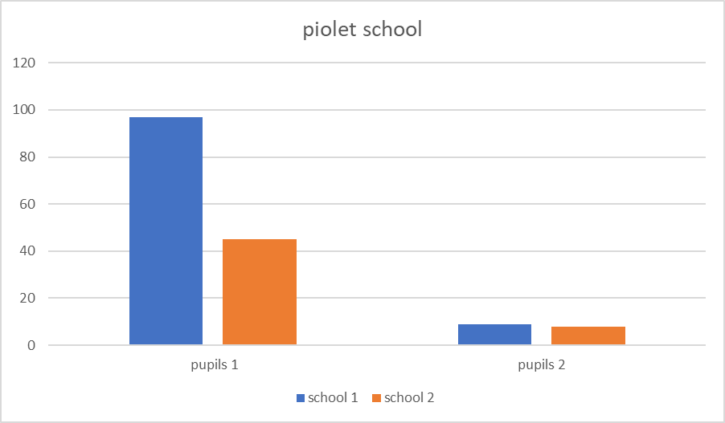Identify the tasks and activities and resource/materials needed
We will do this first with cooperation from the parents and captain that they make their contributions in the sense that they just take what they can spare, for example a bag of cement, it can also be finances, the workers provide food and drink, certain parents make themselves available to carry out construction work
etc.
furthermore we want to work together with some organization local and international organizations to donate computers.

DESIGN AND EXECUTION
We want to start with the construction or setting up of the ICT room, so the construction can be divided into different phases.After these phases of building, construction process, design, design phase, we will prepare for the work planner who will assist us in building this ICT space.

The process will be done in such a way that we need a contractor for the construction who will help us with the drawing of the construction, number of materials and workers and the cost of all this so that we can start building the ICT room.The contractors will then coordinate with his team what they are going to do first, what they first need to start, the amount of material they will use on day 1, the use of water, because all this takes place in a village and is then different.

This is done because the contractor knows how big, wide and long a classroom is, how many meters per student. When all this is in place, we continue with who can help or contribute.Parents also help in the form of food and building materials

Product
Our project is to build an ICT room. We will work on this with the parents, head of the village and national and international organization and also with the curriculum of minov, learning material comes from them. After all this we have a suitable ICT classroom

Why is it SMART?

- CONCLUSION AND FUTURE WORK
  - Personal Reflection
    - Did your Big Idea work? Explain your findings
Our Big Idea will work.At the end of march we will launch our project . We have interviewed a few people from that village(Peto-ondro). The parents are also excited to hear about our plan.
    - Was your project effective?
Our project plan will be effective. The people are interested in this project
    - How well did the project flow?
Our project flowed very well.
    - What were the challenges and successes?
We will ask the captain to help us to connect the parents together,and also the director of the school to organize a meeting so that we can hear what we can do together. The success is that the pupils were excited and participated with everything we told them to do.
    - How can the project be improved?
The project can be improved by asking for donations to the location and computers . All the people who work with the pupils to get motivated.
  - Present an assessment plan for the project design
    - Did the project meet standards?
No, the project did not really meet standards yet.
    - Did the project engage students?
Yes it did because they ask for extra lessons after school twice a week.
    - Did the project encourage higher-level thinking?
The project encourages higher-level thinking. After 1 year or 2 we will look for another school to launch another project.

    - Did the project integrate Technology effectively?
The project integrates technology effectively,because not only for school it works also for other things like sending mail etc. The pupils can also help their parents with this that has to do with ICT.

    - Did the project make an impact?
The project made an impact because the parents saw how their children did at home so they also want to doICT . The people of other villages also want to do ICT.
- ACKNOWLEDGEMENTS
- REFERENCES (Use Google Scholar)
- APPENDIX

The body of the report must be prepared according to the following guidelines.

- Print page numbers in the manuscript. Do not print page number for the title page.
- Tables and Figures must be properly captioned and numbered. These should be placed as close as practicable to their first reference in the text.
- There is no specific page limit but it is recommended that the report is at least 12 pages. Pages should be printed only on one side of 8.5” x 11” paper and the text will be double spaced.
- Use a font that is 12 point and the margins must be at least 1” wide.
- Use boldface for introducing a new headings.
- References must be cited properly in the text of the article.

